Chapter 7 Wave–particle duality and quantum theory
Chapter Test Total marks 47
Name: __________________________ Class: ______ Date: ______
A data sheet with appropriate physics constants will be provided for this test.
Question 1
State two pieces of evidence that support the wave nature of light. For one of these pieces of evidence, explain how it provides evidence for the wave nature of light. Diagrams may be used to assist your explanation. (4 marks)

Question 2
Which one of the following statements about the photoelectric effect is correct?
A The kinetic energy of electrons ejected from a metal surface will increase as the intensity of light incident on the surface is increased.
B The minimum energy of a photon needed to eject an electron from a metal surface varies with the frequency of the incident light.
C For light above the required minimum frequency, an increase in the intensity of the incident light on a metal surface will increase the number of electrons ejected from its surface.
D The photoelectric effect is used as evidence to support the model of light as a transverse electromagnetic wave.
Explain why you think the answer you have chosen is correct. (3 marks)

Question 3
When ordinary white light is looked at through a single polarising sheet, the brightness of light passing through to the observer is reduced by about half. A second polarising sheet can be placed on top of the first sheet in such a way as to have no effect on the brightness of the light passing through. If the second sheet is now rotated 90°, virtually no light now passes through to the observer.
Explain these observations using the appropriate physics principles. (4 marks)

Question 4
Use the information below to answer the questions that follow.
At its simplest, a mobile telephone is a radio transmitter and receiver. When you speak into your mobile phone, the audio signal is converted to an electrical signal by a transducer. The electrical signal is called an audio frequency because its frequencies are in the audio range of 20 to 20 000 Hz, which are of the same frequencies as the audio signals. The oscillating electrons from the alternating current of the electrical signal travel to the transmitting antenna where they are converted to electromagnetic (EM) waves.
The electromagnetic waves from the sender’s phone are picked and relayed on by the mobile telephone towers in the network until they reach the receiver’s telephone. The antenna in the receiver’s phone picks up the electromagnetic waves, which cause the electrons in the receiving antenna to oscillate creating an electrical signal. This signal is converted back to an audio signal heard by the person receiving the telephone call.
a Compare the frequency of oscillations of the electrons in the transmitting antenna to the frequency of the electromagnetic waves sent out by the transmitting antenna. (1 mark)

b Compare the frequency of oscillations of the electrons in the transmitting antenna to the frequency of the oscillation of electrons in the receiving antenna. (1 mark)

c What is the wavelength of an EM wave resulting from an electrical signal with the maximum audio frequency? (2 marks)

d The EM wave generated by the audio input in a phone is carried by a carrier wave. For many mobile networks in Australia, the frequency of the carrier wave is in the 850 MHz band.
i Identify whether the wavelength for an EM wave generated by an audio input at the maximum audio frequency or the wavelength of the carrier wave.
ii Determine by which magnitude (factor) it is longer. (2 marks)

Question 5
Ultraviolet light with a frequency of 1.46 × 10¹⁵ Hz is shone onto the surface of an unknown element. Electrons with a kinetic energy of 1.22 eV are measured being emitted from the surface of the element. From the list of elements below, identify which is the unknown element. Show clear working to support your answer. (5 marks)
Element | Work function (eV)
aluminium | 4.08
beryllium | 5.00
boron | 4.45
carbon | 4.81
gallium | 4.32
manganese | 4.10

Question 6
If a beam of white light is shone through a sample of oxygen gas as illustrated below and the emergent light examined through a spectroscope, rather than a continuous spectrum being observed, there will be a series of dark lines in the spectrum. Explain what causes this series of dark lines. (3 marks)
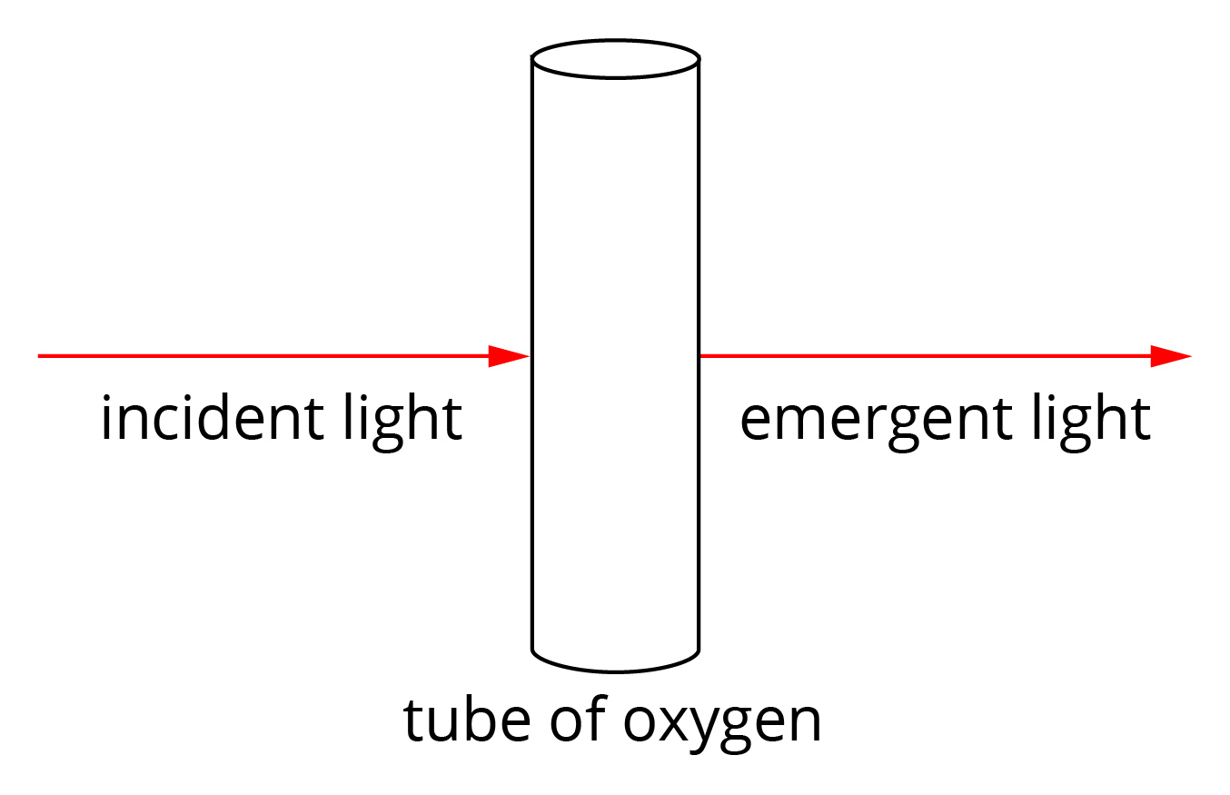

Question 7
The diagram below shows some of the energy levels for a mercury atom.
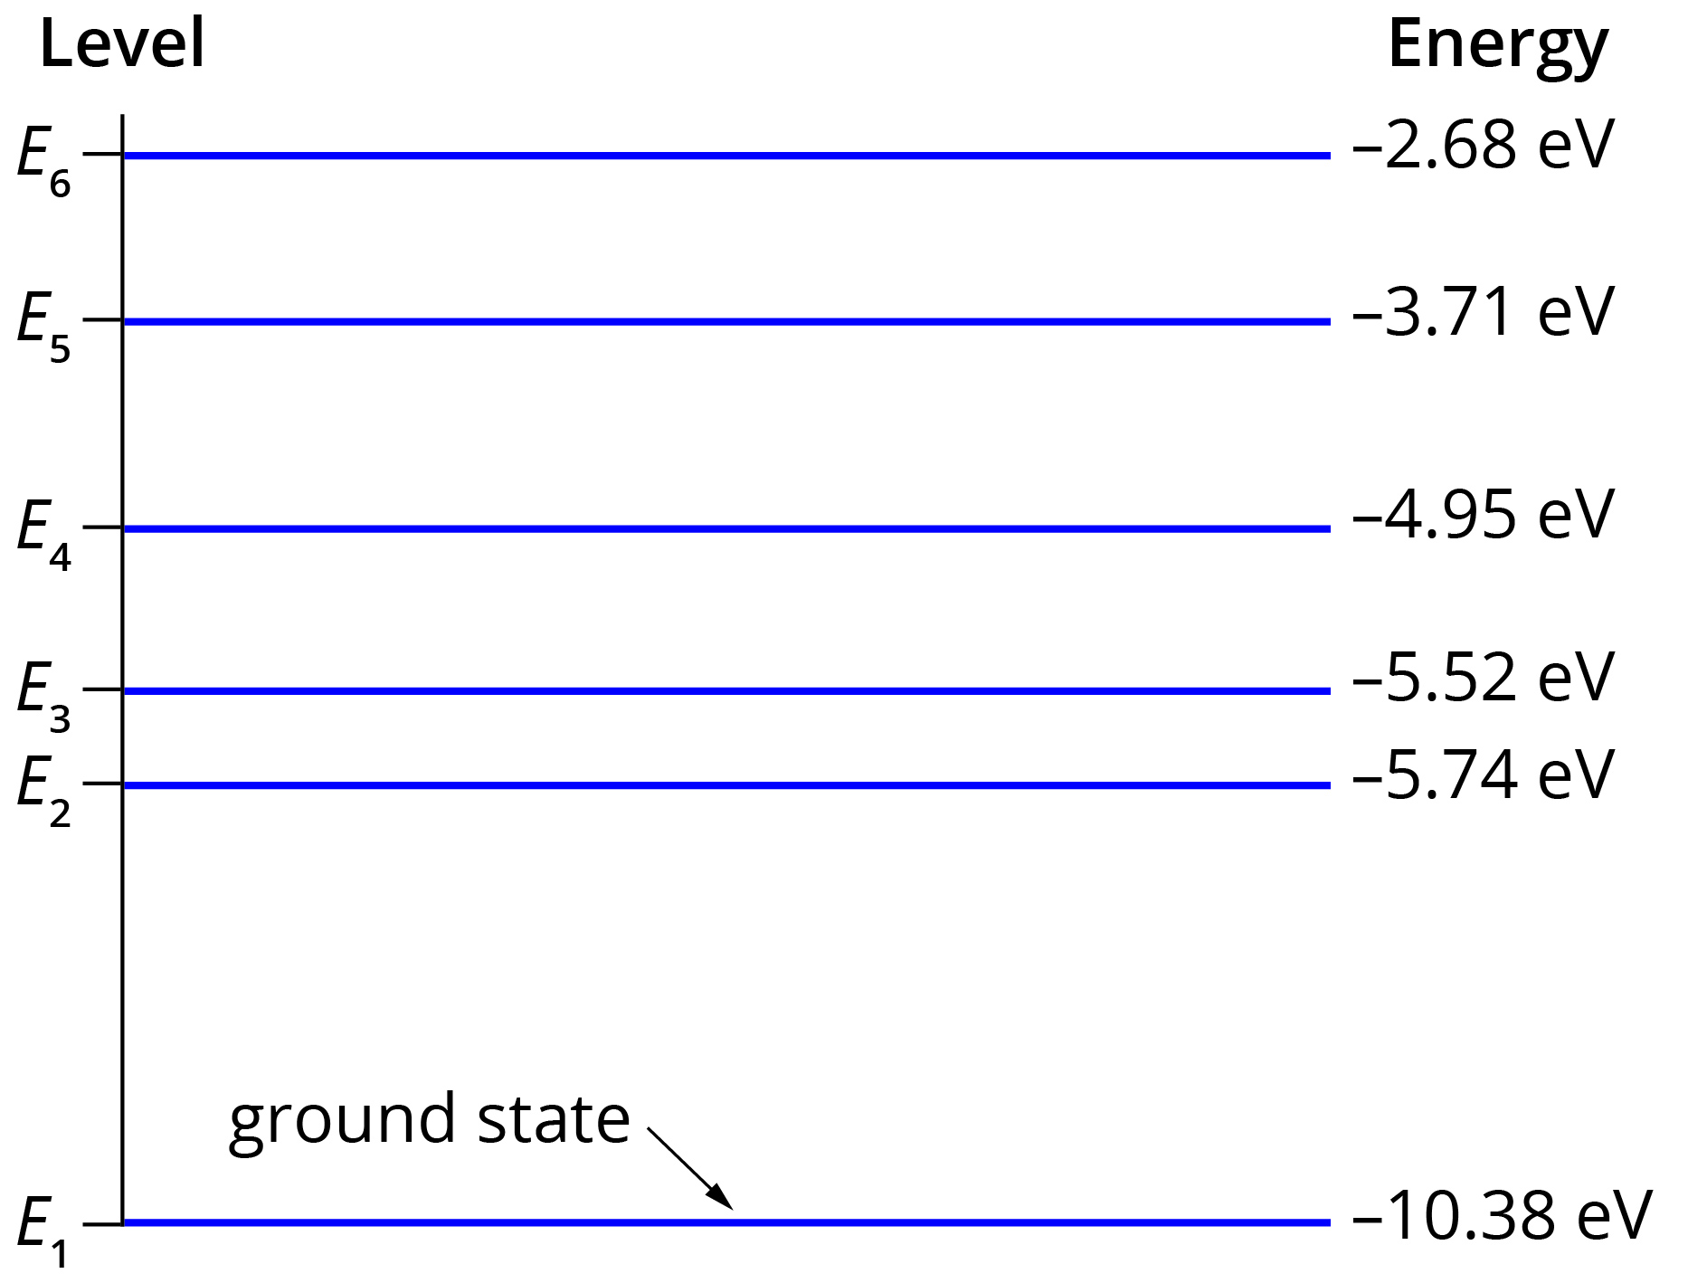

a The line emission spectrum for mercury has a prominent blue line at about 437 nm. Determine between which two energy levels an excited electron will transition to emit light of this wavelength. (4 marks)

b How many different lines could appear in a mercury’s emission spectrum for an electron falling from energy level 4 to the ground state? (2 marks)

Question 8
X-rays can be produced when a high-speed electron strikes a metal target and the electron’s energy is converted to X-rays.
a If an electron with energy of 1.18 × 10⁶ eV produces a photon of maximum possible energy on impact with the target, what is the frequency of the X-ray? (3 marks)

b Some minerals fluoresce red when X-rays are shone onto them. Explain how this occurs. (2 marks)

Question 9
The Bohr model of the hydrogen atom assumes its electron can only orbit the nucleus at certain fixed distances. Explain how de Broglie’s model of wave–particle duality of all matter can be used to support the idea of fixed orbits (or more correctly, fixed orbitals). (2 marks)

Question 10
What is the wavelength of an electron with kinetic energy of 40 eV? (5 marks)

Question 11
Using appropriate estimates for a familiar macroscopic object and the appropriate mathematical relationship, explain why we do not experience the wave–particle duality for macroscopic objects. (4 marks)

